NAME : SHYAM SUNDAR K REG NO : 241801268
DEPT : AI&DS
Experiment :17

- Write a code in PL/SQL to develop a trigger that enforces referential integrity by preventing the deletion of a parent record if child records exist.
CREATE OR REPLACE TRIGGER trg_prevent_parent_delete BEFORE DELETE ON parent_tab

FOR EACH ROW DECLARE
v_count NUMBER; BEGIN
SELECT COUNT(*) INTO v_count FROM child_tab WHERE parent_id =
:OLD.parent_id;
IF v_count > 0 THEN
RAISE_APPLICATION_ERROR(-20001, 'Cannot delete parent: child records exist.');

END IF; END;
/

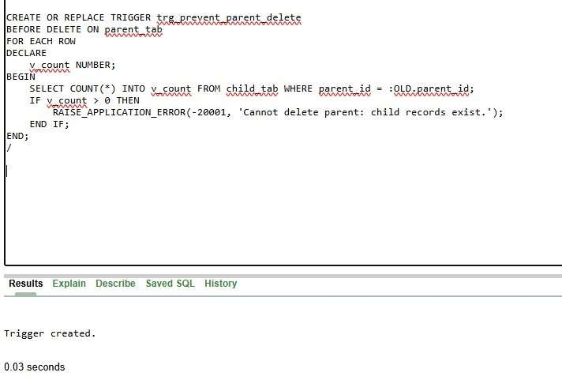
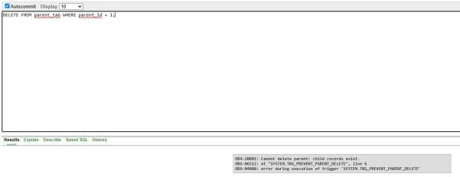

Write a code in PL/SQL to create a trigger that checks for duplicate values in a specific column and raises an exception if found.
CREATE OR REPLACE TRIGGER trg_no_duplicate_name BEFORE INSERT OR UPDATE ON students

FOR EACH ROW DECLARE
v_count NUMBER;

BEGIN
SELECT COUNT(*) INTO v_count FROM students
WHERE UPPER(student_name) = UPPER(:NEW.student_name)
AND (:NEW.student_id IS NULL OR student_id <> :NEW.student_id);

IF v_count > 0 THEN
RAISE_APPLICATION_ERROR(-20002, 'Duplicate student name not allowed.'); END IF;

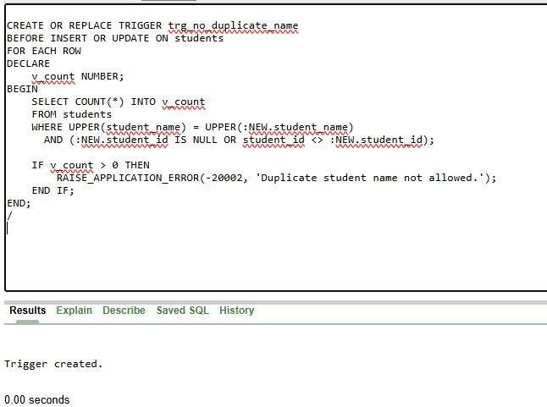
END;

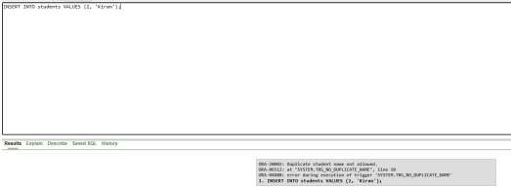
/

Write a code in PL/SQL to create a trigger that restricts the insertion of new rows if the total of a column's values exceeds a certain threshold.

CREATE OR REPLACE TRIGGER trg_salary_limit BEFORE INSERT ON dept_salary

FOR EACH ROW DECLARE
v_total NUMBER;

BEGIN
SELECT NVL(SUM(salary), 0) INTO v_total FROM dept_salary; IF v_total + :NEW.salary > 100000 THEN
RAISE_APPLICATION_ERROR(-20003, 'Cannot insert: total salary limit exceeded.');

END IF; END;
/

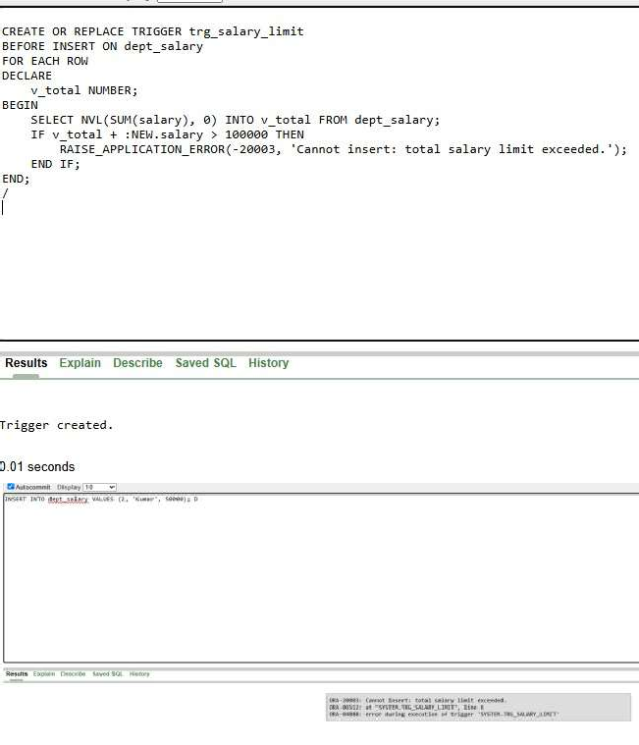

Write a code in PL/SQL to design a trigger that captures changes made to specific columns and logs them in an audit table.

CREATE OR REPLACE TRIGGER trg_audit_salary AFTER UPDATE OF salary ON emp_master

FOR EACH ROW

BEGIN
INSERT INTO emp_audit VALUES (
:OLD.emp_id,
:OLD.salary,
:NEW.salary, SYSDATE

); END;
/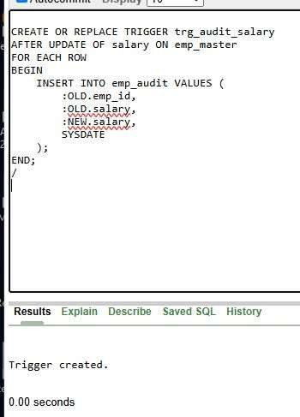

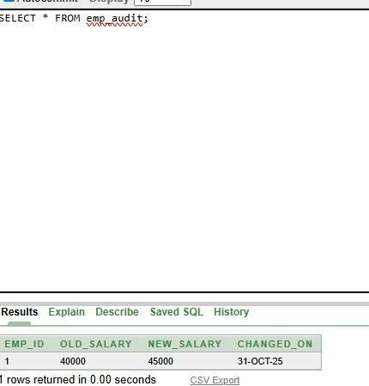

Write a code in PL/SQL to implement a trigger that records user activity (inserts, updates, deletes) in an audit log for a given set of tables.
CREATE OR REPLACE TRIGGER trg_emp_activity AFTER INSERT OR UPDATE OR DELETE ON emp_data FOR EACH ROW

BEGIN
IF INSERTING THEN
INSERT INTO emp_log VALUES (USER, 'INSERT', :NEW.emp_id, SYSDATE); ELSIF UPDATING THEN
INSERT INTO emp_log VALUES (USER, 'UPDATE', :OLD.emp_id, SYSDATE); ELSIF DELETING THEN
INSERT INTO emp_log VALUES (USER, 'DELETE', :OLD.emp_id, SYSDATE); END IF;

END;
/

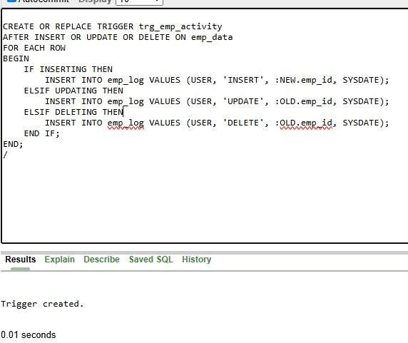
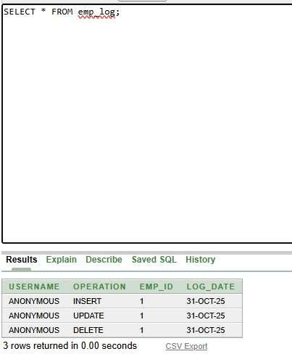

Write a code in PL/SQL to implement a trigger that automatically calculates and updates a running total column for a table whenever new rows are inserted.
CREATE OR REPLACE TRIGGER trg_running_total BEFORE INSERT ON sales

FOR EACH ROW DECLARE
v_total NUMBER;

BEGIN
SELECT NVL(SUM(amount), 0) INTO v_total FROM sales;
:NEW.running_total := v_total + :NEW.amount; END;
/
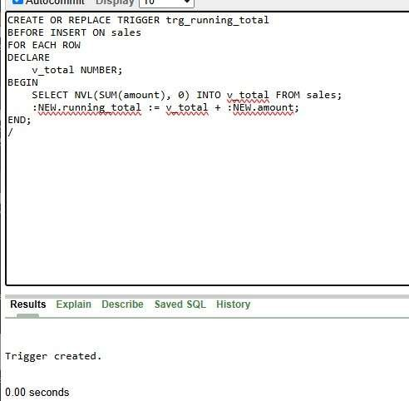

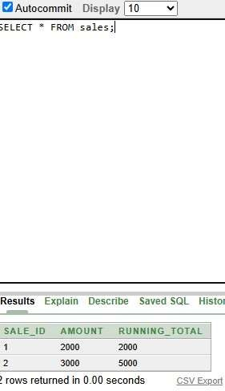

Write a code in PL/SQL to create a trigger that validates the availability of items before allowing an order to be placed, considering stock levels and pending orders.
CREATE OR REPLACE TRIGGER trg_check_stock BEFORE INSERT ON orders

FOR EACH ROW DECLARE
v_available NUMBER; BEGIN
SELECT quantity INTO v_available FROM stock WHERE item_id =
:NEW.item_id;

IF :NEW.quantity > v_available THEN
RAISE_APPLICATION_ERROR(-20004, 'Not enough stock available for this order.');

END IF; END;

/
